6/16/2018

Scott Kaeneman

Boston university

Database Design and Implementation for Business

MET CS 669

Table of Contents

**Part A. Structural Business Rules** **1**

**Part B. Conceptual ERD4**

**Part C. Logical ERD 5**

**Part D. Screenshots of SQL addressing the 5 aspects 6**

**Part E. Index Creation 12**

# Part A. Structural Business Rules

Aspect 1: New Products

*This occurs when a seller plans to sell a product it has not sold before.*

1. The seller searches Amazon’s product list to determine if another seller is already selling the product.

**A SELLER must search one or more product listings; Each LISTING is searched by a seller.**

2. If a different seller is already selling the product, a new listing is not required; the seller re‐uses the same listing.

**A LISTING may describe one or more unique products for sale; a unique PRODUCT must be shown in a listing.**

3. If the product is not yet sold on Amazon, a new listing is created with the product’s name, description, price, and other relevant items. Every product added is linked to a product category (all categories are predefined by Amazon), for example, “Computers”, “Electronics”, “Appliances”, and similar.

**Every PRODUCT must belong to a category; a CATEGORY is comprised of similar products.**

Aspect 2: Product Delivery

*This occurs when a seller sends one or more units of a product to Amazon so that they can be sold.*

1. The seller ships one or more units of a product to Amazon’s warehouse, along with information that indicates to Amazon what the product is, how many units there are, and the condition (new, used, etc …).

**A SELLER ships one or more units of a product; Each product UNIT is shipped by at least one seller.**

**Each UNIT is comprised of only one product; a PRODUCT is counted as a single unit.**

2. After Amazon receives the product(s), it updates the seller’s inventory so that customers can

purchase the product.

**Each PRODUCT must belong to a sellers inventory; A SELLERS_INVENTORY may contain zero to many products.**

Aspect 3: New Customer Accounts

*This occurs when a customer signs up for an account on Amazon, so they can begin purchasing products.*

1. The customer provides Amazon with basic information including a username, an address, phone number, and an email address.

**A CUSTOMER may have one or more accounts; each ACCOUNT is associated with one customer.**

2. Amazon creates an account for the customer, enabling the customer to purchase products. **A CUSTOMER can purchase 0 to many products; A PRODUCT is purchased by at least one customer.**

Aspect 4: Product Purchases

*This occurs when a customer purchases a product from Amazon that was*

*provided by a seller.*

1. The user logs in to Amazon under their account.

**An ACCOUNT is logged into by a customer; Each CUSTOMER has one or more accounts.**

2. A customer selects one or more products on Amazon’s website. When selecting a product, the customer is actually selecting a particular seller’s inventory while doing so, though they might not realize this because the process is seamless on Amazon’s website.

**Each CUSTOMER may select from a sellers inventory; A SELLERS_INVENTORY is selected by 0 to many customers.**

3. The customer selects a shipping speed (super saver shipping, standard shipping, two‐day, one‐day) and finalizes their choices.

**A CUSTOMER selects one shipping speed; a SHIPPING_SPEED is selected by one to many customers.**

4. Amazon decrements the seller’s inventory for the products purchased.

**Every SELLERS_INVENTORY is decremented when one or more products are purchased; Each PRODUCT is a part of some sellers inventory.**

5. Amazon creates an order which tracks which customer purchased which products from which sellers.

**A PACKAGE must be linked to a customers order; an ORDER contains one customers package.**

Aspect 5: Product Shipment

*This occurs when Amazon ships the products a customer purchased.*

1. Amazon packages up the purchased products, and assigns an identifier to package so that it can be tracked.

**Each PACKAGE is assigned one identifier; An IDENTIFIER is assigned to one or more packages.**

2. Amazon links the package to the customer’s order.

**A PACKAGE must be linked to a customers order; an ORDER contains one or more packages.**

3. Amazon ships the package to the default address linked to the customer’s account.

**A SHIPMENT contains one or more packages; a PACKAGE must belong to only one shipment.**

**An ACCOUNT address will receive one or more shipments; A SHIPMENT is sent to only one account address.**

4. Amazon notifies the customer that it has been shipped and provides the customer with the tracking ID.

**Every PACKAGE generates a notification; Each NOTIFICATION belongs to one and only one package.**

**Each IDENTIFIER is part of a notification; Every NOTIFICATION lists one package identifier.**

**Each Notification is sent to one user account; an ACCOUNT may receive one or more notifications.**

# Part B. Conceptual ERD

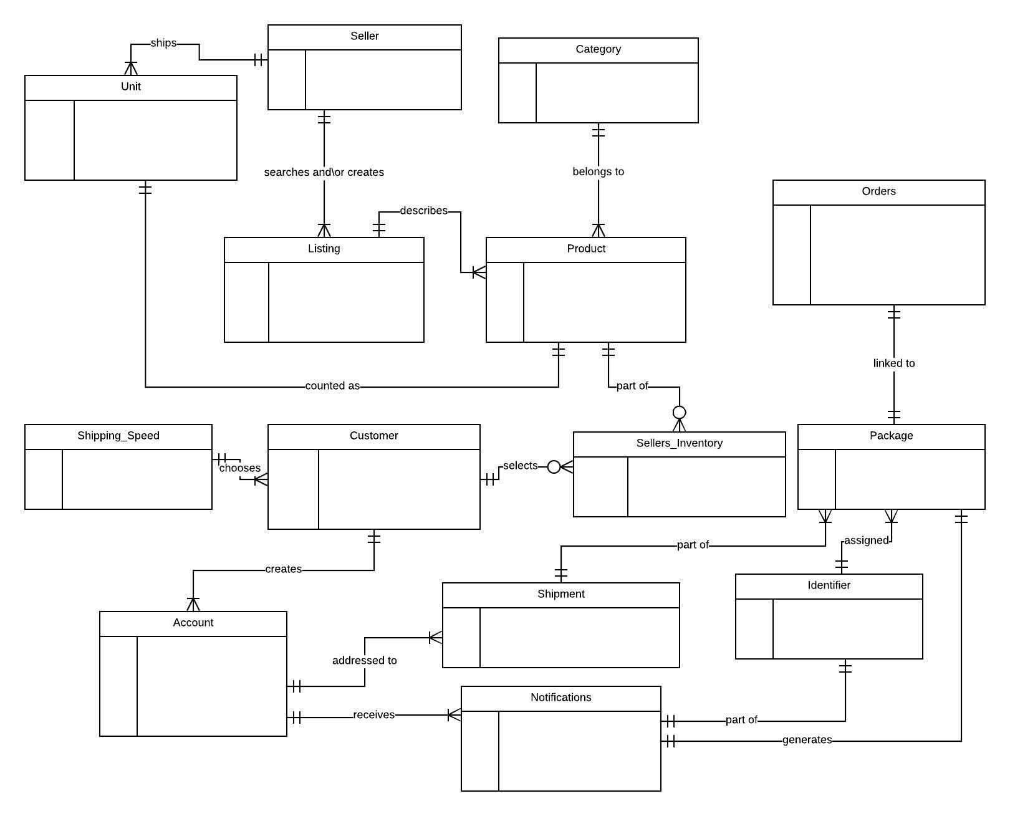

# Part C. Logical ERD

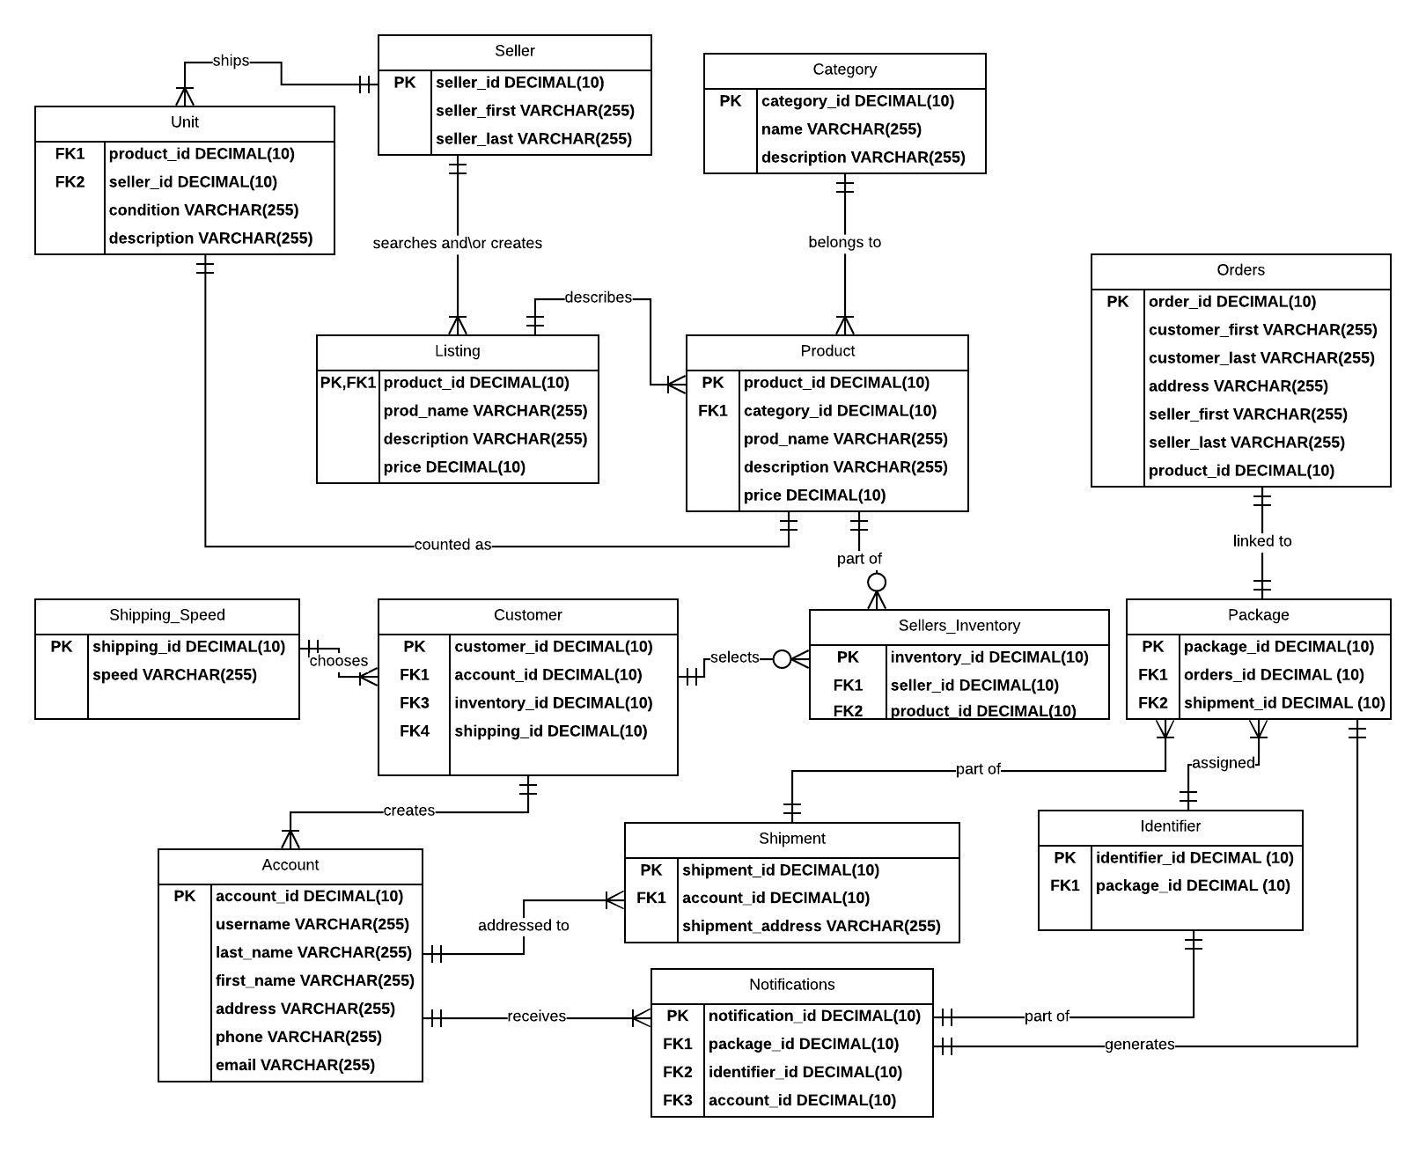

# Part D. Screenshots of SQL addressing the 5 aspects

Aspect 1: stored procedure creation (screenshot unable to display all code)

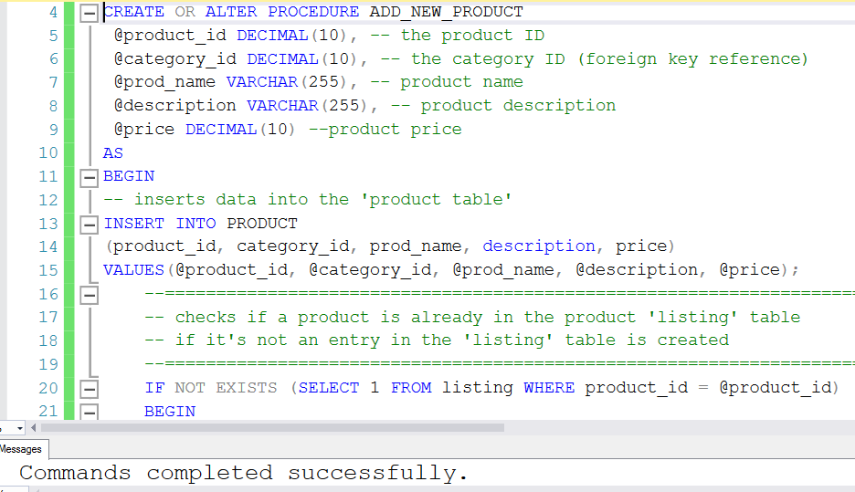

Aspect 1: stored procedure execution (code truncated in screenshot)

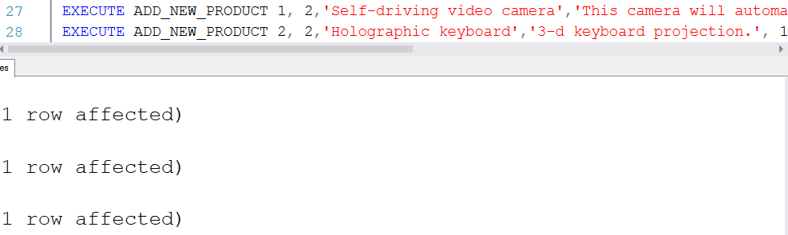

Aspect 1: query execution

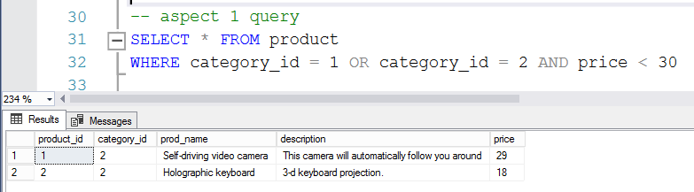

Aspect 2: stored procedure creation

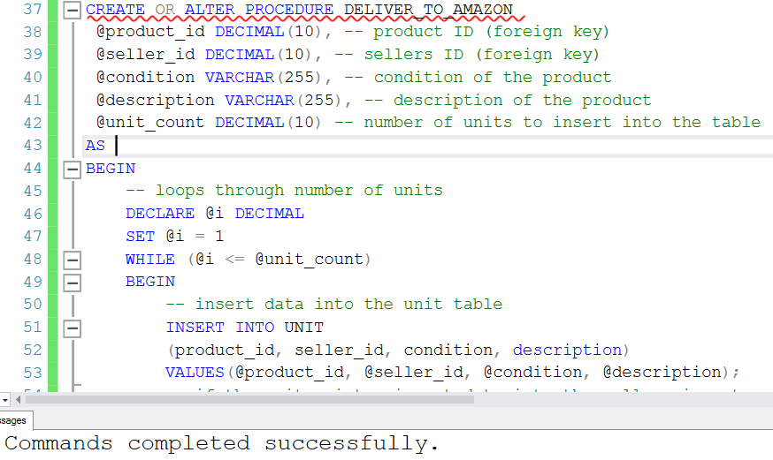

Aspect 2: stored procedure execution

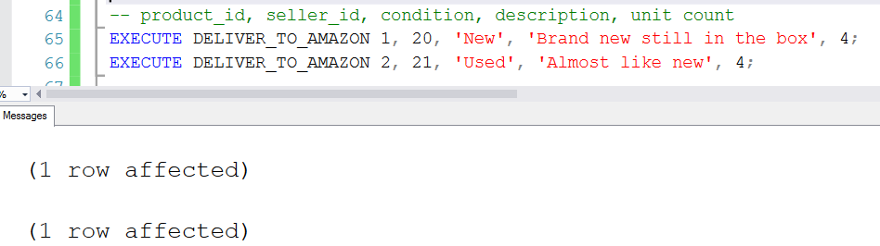

Aspect 2: query execution

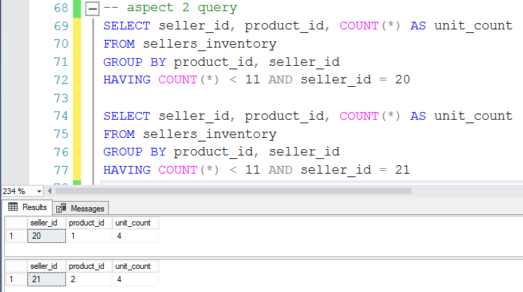

Aspect 3: stored procedure creation (not all code could be shown in screenshot)

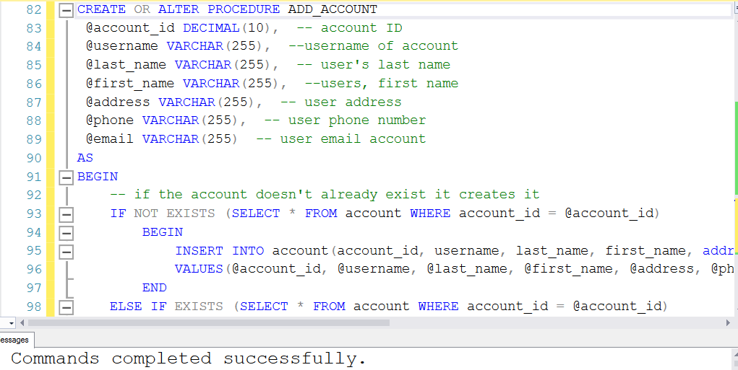

Aspect 3: stored procedure execution

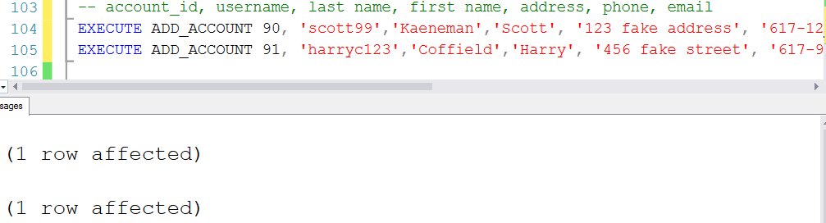

Aspect 3: query execution

Added 6 additional test accounts that all have the same last name of ‘Test_name’.

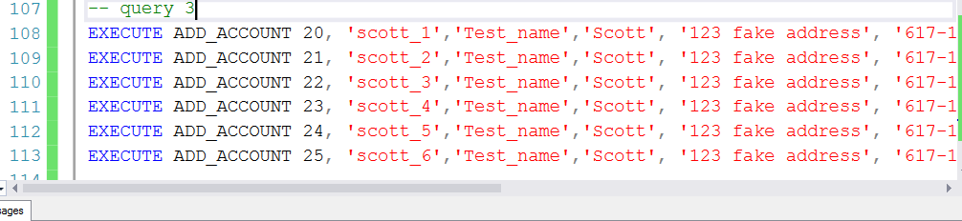

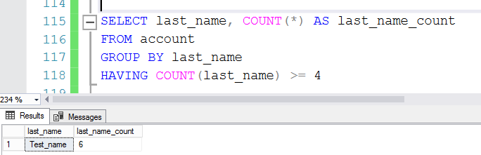

Aspect 4: stored procedure creation

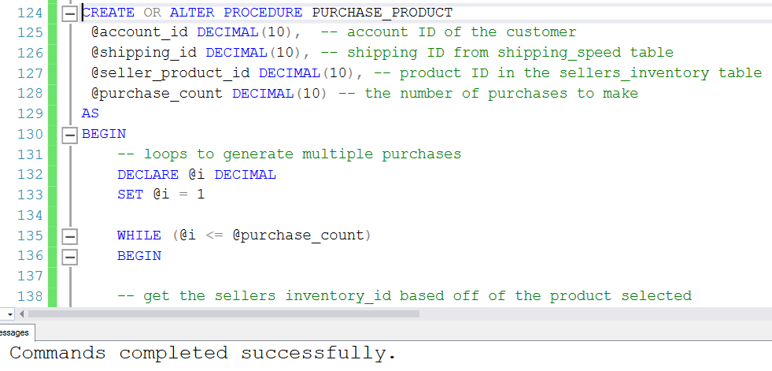

Aspect 4: stored procedure execution

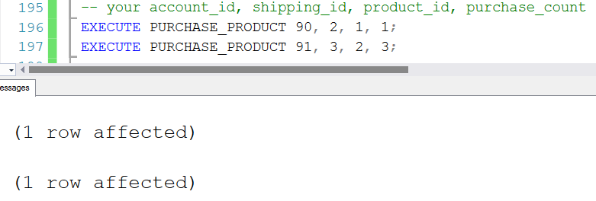

Aspect 4: query execution

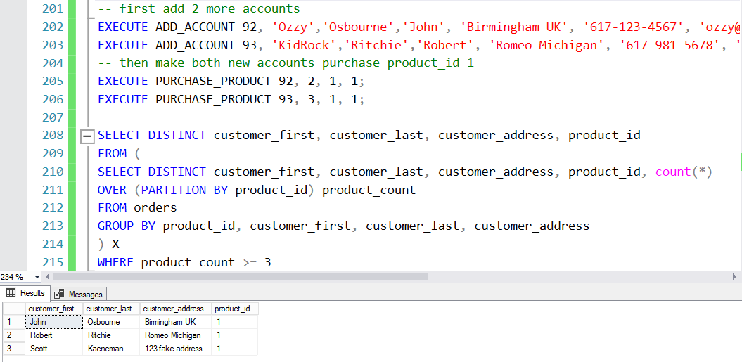

Aspect 5: stored procedure creation (additional code cut off by screenshot)

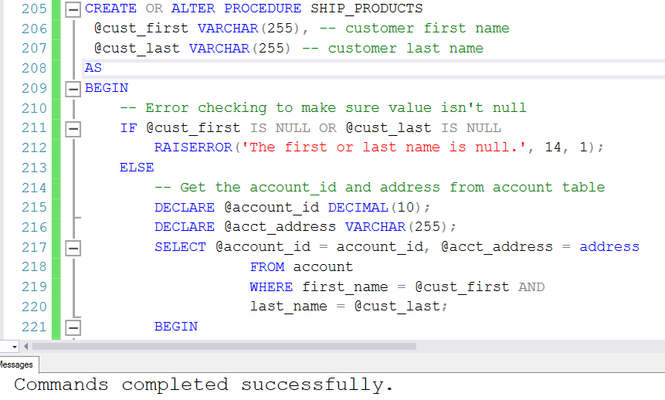

Aspect 5: stored procedure execution

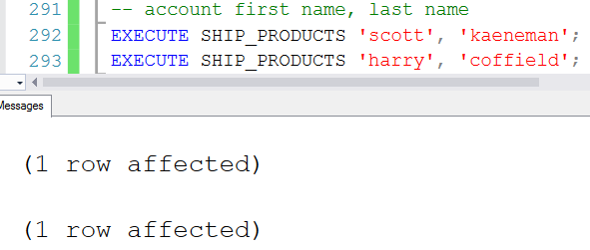

Aspect 5: query execution

This query uses aggregation to get a count of how many packages a user account has ordered and puts them in descending order.

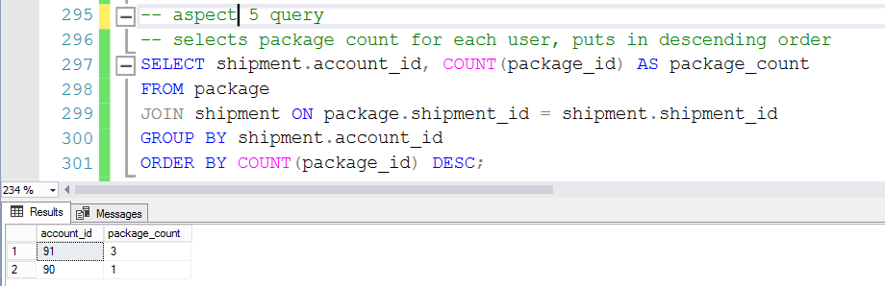

# Part E. Index Creation

An index was created on the Package table’s shipment_id column because of the fact that it is a foreign key and references the Shipment table. Also the Package and Shipment table are joined in a query on the shipment_id column which was another reason it was chosen to have an index created on it.

